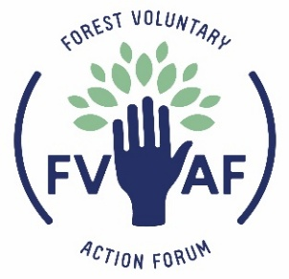   | CONFIDENTIAL  PERSONAL INFORMATION

Application for the post of: Community Connector | Our reference no.

Surname: | First Name(s):
Previous Name(s):

Address: | Home Telephone Number:  Mobile Number:  Email:
 | National Insurance Number:

Period of notice required by your current employer/availability to commence employment:

Do you have a current personal pension plan? No

If yes, please give details

Do you require a work permit? | Yes | No
Are there any restrictions on you being employed in the UK?

If yes please give details:

This post is exempt under the Rehabilitation of Offenders Act:
As such, you are required to declare all convictions regardless of whether or not they are spent.
Please note that the successful candidate will undergo an enhanced DBS check.
Have you ever been convicted of a criminal offence? | Yes | No
If yes, please give details.

Have you had a police caution or formal warning? | Yes | No
Do you have any unspent convictions or police/court matters pending? | Yes | No
If yes, please detail on a separate sheet with your name on it. Failure to disclose may disqualify your application or lead to dismissal without notice.

Have you ever had safeguarding allegations made against you whether founded or unfounded? | Yes | No
If yes, please give details and outcomes.

Please give the names, addresses and telephone numbers of two references. One should be your current or most recent employer. Please do not use relatives. We will normally not approach either referee until after the interview. Please note, we reserve the right to seek references at any point in the recruitment process. If you have any concerns about this, please contact the CEO to discuss these issues or indicate as shown.
Name:  Address:  Telephone No:  In what capacity are they known to you?  Would you prefer your referee to be contacted after interview, should you be shortlisted? | Name:  Address:  Telephone No:  In what capacity are they known to you?  Would you prefer your referee to be contacted after interview, should you be shortlisted?

Declaration

I hereby declare that the statements contained in this application is true and correct. I understand that any deliberate false or misleading information, or omissions of information relevant to safeguarding aspects of this role, may disqualify my application or may render my Contract of Employment, if I am appointed, liable to termination.

Signature: Date:

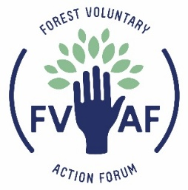 | CONFIDENTIAL  APPLICATION FOR EMPLOYMENT

Application for the post of: Community Connector | Our reference no.
Education:
Please give brief details of your secondary and further education (full and part time) including dates, subjects and qualifications.

Training:
Please give brief details of vocational training completed in the past 5 years including dates, subjects and qualifications.

Do you hold a current full driving licence?

Employment record
Please give details of your last ten years employment history beginning with your current or most recent employer. Continue on a separate sheet if necessary (include any voluntary work or time out of work where appropriate). Please note that gaps in employment must be accounted for.

 | Employer’s name and address | Dates employed | Job title and brief description of duties | Reason for leaving
Supporting Statement and Evidence
Please give full details of skills, knowledge and experience that meet the Job Description and Person Specification provided, including promoting and safeguarding the welfare of children and young people (continue on a separate sheet if necessary).

THANK YOU FOR COMPLETING THIS APPLICATION FORM AND FOR YOUR INTEREST

Data Protection Act:
FVAF will only process the information you have provided in this application form for the purpose of recruitment and selection and, if you are successful in securing this position, for lawful purposes related to your employment. Your details will be kept both electronically and in hard copy in line with GDPR compliance. We will not disclose this information about you to outside organisations or third parties unless there is a legal requirement to do so.
CONFIDENTIAL

MONITORING FORM

Forest Voluntary Action Forum is striving to be an Equal Opportunities employer and seeks to ensure that all applicants for employment are judged on merit. To allow us to continue the development of our Equality and Diversity Policy, we ask that you provide the following information that will be used for monitoring purposes only and form no part of the selection process.

- ETHNICITY

Please describe your ethnic origin in the way you consider is the most appropriate

- DISABILITY

Would you consider yourself to have a disability?

If yes, then what is the nature of the disability?

- GENDER

Are you: Male ……….. Female ……… Other …………

- DATE OF BIRTH

- WHERE DID YOU FIND OUT ABOUT THIS POST

Please do not put your name on this sheet

Thank you for helping us with this information

